LLM Prompt Eval Registry Pipeline
Database design and Alembic migration learning record
This document reconstructs the schema from its first migration through the current prompt registry and evaluation model. It explains each defect, the reason for every correction, the migration techniques used, the errors encountered, and the practices that remain open.
Project
fastapi_eval_prompt_registry
Recorded through migration fdd324cb4b25

Purpose and current conclusion
The original schema captured the right domain nouns but did not yet preserve the full causal chain from prompt family to prompt version, evaluation run, golden example, and individual result. The current model establishes that chain and records the evidence needed to compare prompts: model identity, raw and normalized outputs, token usage, latency, cost, pass or fail, and error status.
The migration history is valuable because it shows the difference between changing ORM code and safely changing an existing PostgreSQL schema. The successful migration on a new database confirms that the chain can reach the current head. It does not make every deferred design choice complete; the remaining items are documented separately.

Scope
- The initial SQLAlchemy schema and the original Alembic table creation.
- Four intermediate schema variants and the latest schema.
- Every model issue discussed during the review and its resolution status.
- Alembic patterns used for type conversion, data backfill, foreign-key repair, enum migration, constraints, and downgrade behavior.
- Errors encountered during implementation and the technical reason for each error.
- Deferred work in factories, seed data, evaluation-run lifecycle, and data-governance fields.

System model
PromptFamily 1 -> many PromptVersion
PromptVersion 1 -> many EvalRunner
EvalRunner 1 -> many EvalResult <- 1 GoldenExample
A prompt family identifies a stable task such as support ticket triage. Each immutable prompt version contains one implementation of that task. An evaluation run tests one prompt version with one model. Each result records the outcome for one golden example. This structure makes accuracy, latency, and cost traceable to the exact prompt and model configuration.

Authorship and implementation record
The project author implemented the model redesign and generated the migration sequence. The final alignment migration was reviewed collaboratively. At the author's explicit request, a narrowly scoped direct edit corrected prompt-family enum definitions, enum create and drop placement, malformed constraint nesting, and explicit names for one unique constraint and two foreign keys. The author ran the database commands and reported that the migrations completed successfully.

Original database design
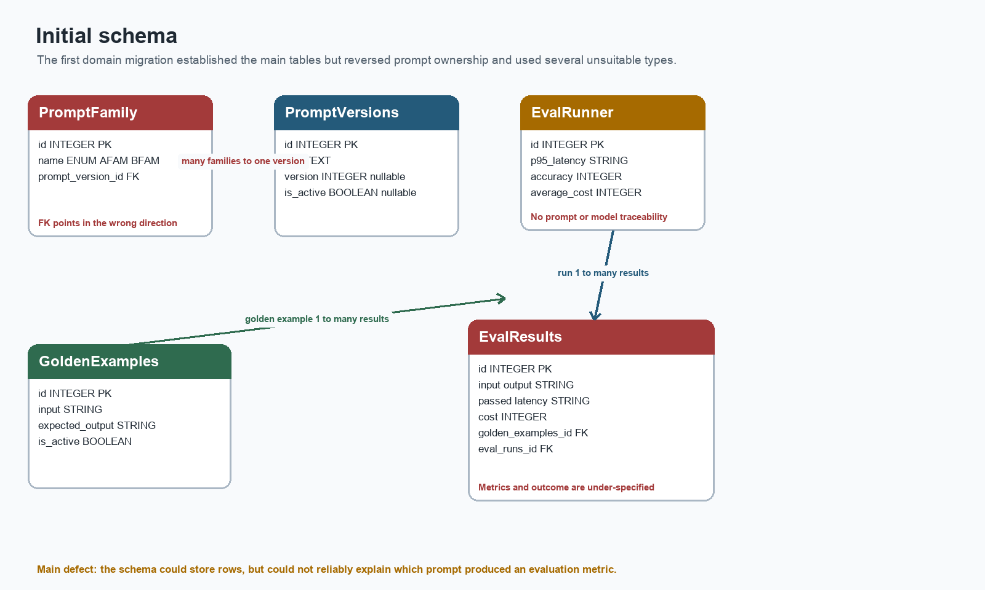
Figure 1 Initial schema created by revision a09c6e7839a9

Initial tables and fields
Table | Initial fields | Initial problem
prompt_families | id; name enum; prompt_version_id | The foreign key made many families belong to one version.
prompt_versions | id; text; version integer; is_active | Semantic versions could not be represented cleanly; version and active state were nullable.
golden_examples | id; input; expected_output string; is_active | The label was initially unconstrained text.
eval_runs | id; p95_latency string; accuracy integer; average_cost integer | The run had no prompt or model identity, and its metrics used unsuitable types.
eval_results | id; input; output; passed; latency; cost; two foreign keys | Passed and latency were strings, cost was integer, and raw versus normalized output was not distinguished.
dummy | id; username; email | A migration-learning table remained outside the domain model.

Why the original relationship was reversed
A one-to-many foreign key belongs on the many side. The original prompt_version_id column was placed on prompt_families, so multiple family rows could point to one version. The intended model is the reverse: one family owns multiple versions. Moving the foreign key to prompt_versions as prompt_family_id corrected the cardinality.
Original: PromptVersion 1 ── * PromptFamily
Required: PromptFamily 1 ── * PromptVersion

Why the original run was not auditable
An eval_runs row contained aggregate metrics but did not identify the prompt version or model that produced them. Accuracy of 0.92 is not useful evidence if the database cannot answer which prompt, model, or dataset generated that value. Adding prompt_version_id and model_used created the first usable traceability link. Dataset identity remains open.

Schema evolution
The schema evolved through corrective migrations rather than one replacement. This section groups those revisions into four meaningful variants. Each variant isolates a different database-design lesson.

Variant one Type repair
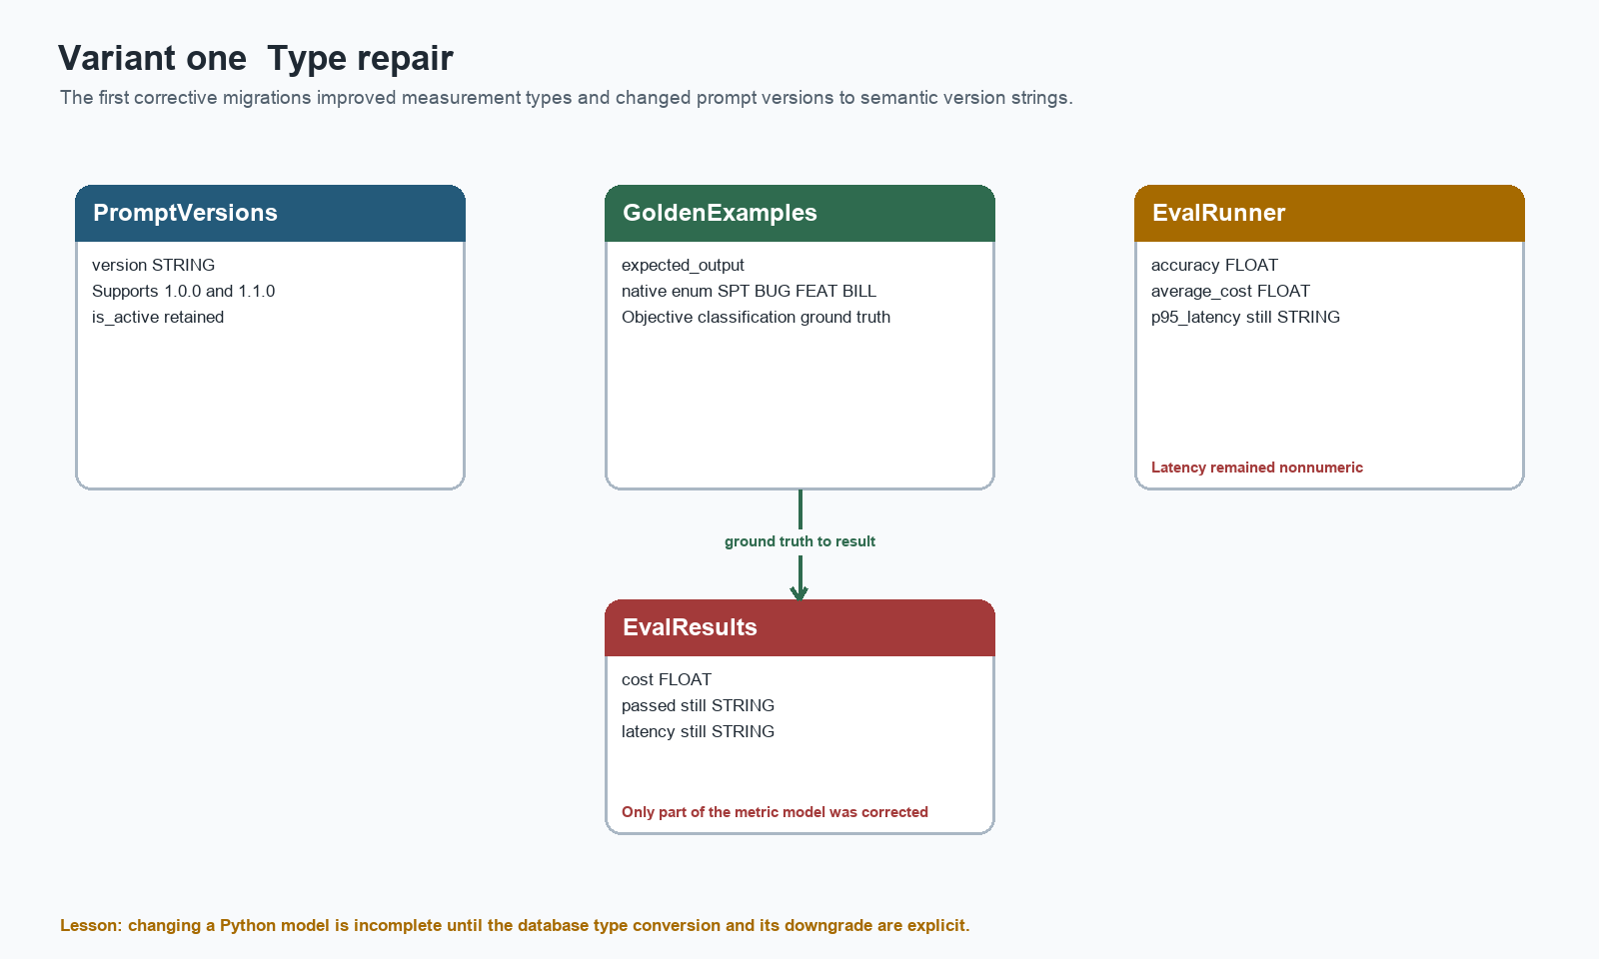
Figure 2 Type corrections across revisions c84a39cb88c3 and 69cf56477a15
The first corrections converted cost and aggregate metrics from integer to float, introduced an output-category enum, and changed prompt version from integer to string. The string version supports semantic versions such as 1.0.0. These migrations also exposed an important Alembic rule: PostgreSQL often requires an explicit USING expression when a type has no implicit cast.

Variant two Relationship repair
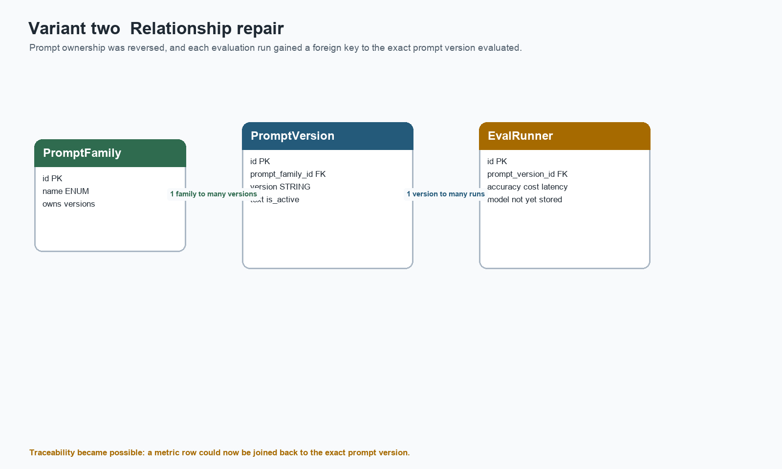
Figure 3 Corrected ownership and run traceability in revisions 826cd905a355 and e711cb279e0a
The prompt family foreign key moved to prompt_versions, and eval_runs gained prompt_version_id. The migration used a three-step pattern for populated tables: add a nullable column, backfill existing rows, then enforce NOT NULL. The pattern is valid, but the specific hard-coded backfills to IDs 1 and 2 were safe only for a known development database.

Variant three Observability and audit data
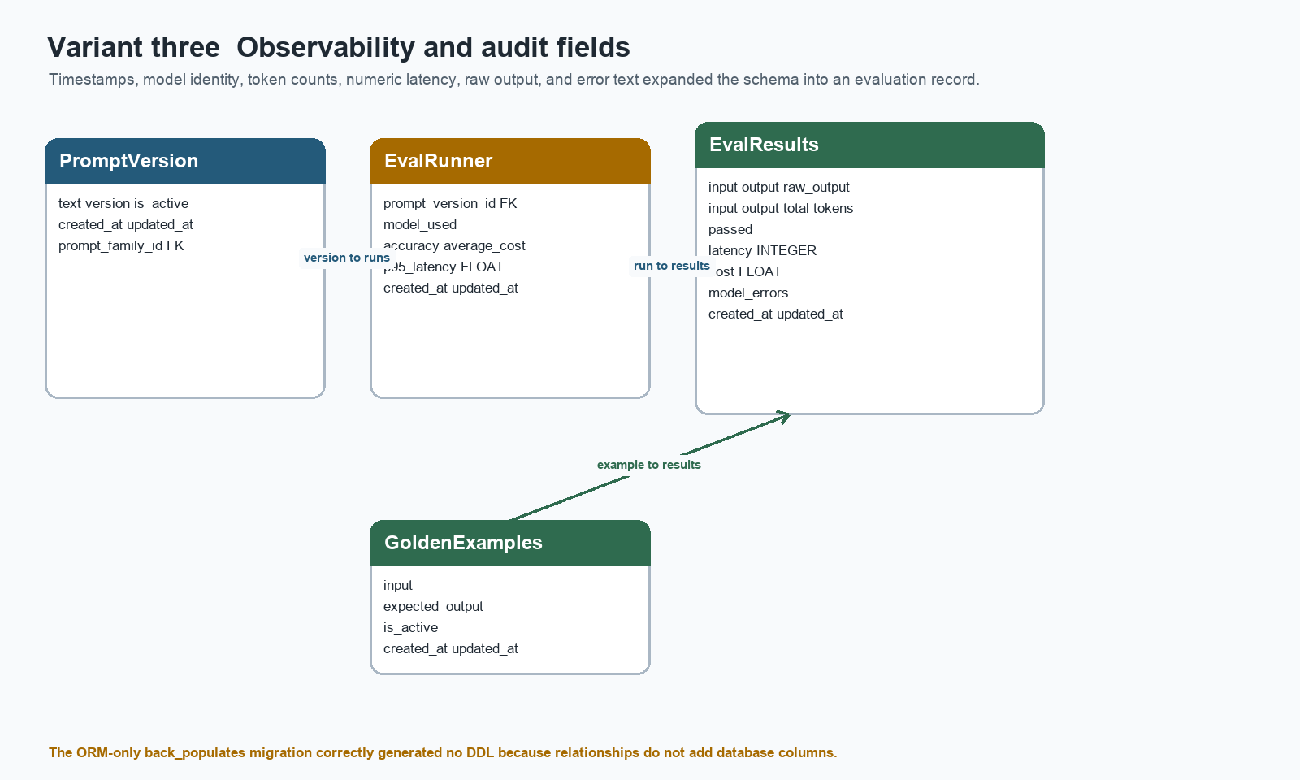
Figure 4 Measurement and audit fields added by revisions 16d1d49ff4ce, dbff4232fa46, and 6697e66ccd26
Timestamps and model identity made runs attributable. Token counts enabled cost explanation. Numeric latency enabled aggregation and percentile calculations. Raw output preserved the provider response for debugging, while error text made failed requests observable. The p95 metric changed to float because percentile calculations may produce fractional milliseconds.

Variant four ORM navigation
Revision 9ae3e45f1d0b contained no database operations. That empty migration was expected: relationship and back_populates configure Python object navigation, while foreign keys define database integrity. Alembic detects columns, constraints, indexes, and types; it does not need DDL for an ORM-only relationship change.
GoldenExample.eval_results ↔ EvalResult.golden_example
EvalRunner.eval_results ↔ EvalResult.eval_run
PromptFamily.prompt_versions ↔ PromptVersion.prompt_family
PromptVersion.eval_runners ↔ EvalRunner.prompt_version

Migration history and techniques
Revision | Kind | Change | Technique or lesson
47335c58910c | Initial learning migration | Created dummy table | Baseline create and drop table operations
a09c6e7839a9 | Domain schema creation | Created five prompt and eval tables | Initial DDL and foreign keys
8780ad61cb55 | Early enum attempt | Attempted expected_output conversion | Autogenerated code required manual review; type used the wrong argument and lacked a complete enum
c84a39cb88c3 | Corrective type migration | Created output enum; changed cost and aggregate metrics to float | Explicit PostgreSQL enum creation and USING cast
69cf56477a15 | Version type migration | Changed prompt version integer to string | Semantic version storage
826cd905a355 | Relationship migration | Moved family/version foreign key | Drop old FK, add nullable column, backfill, enforce NOT NULL, create new FK
e711cb279e0a | Traceability migration | Added prompt_version_id to eval_runs | Backfill then enforce required relationship
16d1d49ff4ce | Audit migration | Added timestamps and model_used | Add nullable, backfill with NOW or model value, then enforce NOT NULL
dbff4232fa46 | Instrumentation migration | Added token counts and numeric latency | Backfill counters and use explicit casts
6697e66ccd26 | Output observability | Added raw output and model errors; p95 became float | Preserve unparsed response and failures
9ae3e45f1d0b | ORM-only migration | No DDL | back_populates changes do not modify tables
fdd324cb4b25 | Schema alignment | Normalized fields, statuses, enums, constraints, and names | Autogenerate plus manual PostgreSQL corrections

Migration categories demonstrated
Migration category | Example in this project | Practice
Create and drop | Initial tables and removal of dummy | Define upgrade and a meaningful reverse downgrade.
Additive schema | Timestamps, tokens, raw_output, status | Add fields without rewriting unrelated tables.
Type conversion | String latency to integer; string passed to Boolean | Use postgresql_using when PostgreSQL has no safe implicit cast.
Data migration | Populate timestamps, counters, model_used, and foreign keys | Backfill data before adding NOT NULL.
Relationship reshape | Move prompt foreign key to the many side | Drop old constraints before removing columns; recreate the intended FK.
Constraint migration | Unique family name and family plus version | Use explicit names so downgrade can target the right object.
Enum migration | Native enum to VARCHAR plus CHECK | Manage the standalone PostgreSQL type and its allowed values deliberately.
ORM-only change | back_populates | Expect no DDL when only Python navigation changes.
Alignment migration | fdd324cb4b25 | Treat autogenerate as a draft and review every operation.

Why a new database was appropriate
The database contained synthetic data, an obsolete prompt-family enum, reversed ownership, and several transitional column types. A new development database removed the risk of preserving meaningless IDs and allowed every migration to be tested from an empty state. This choice was appropriate during schema design. Once real or shared data exists, the correct approach changes: preserve the database, write forward migrations, backfill from defensible source data, and test rollback or recovery separately.
A new database does not repair a bad migration by itself. Its value is that it exposes whether the complete migration chain can reproduce the intended schema without hidden state from earlier manual changes.

Errors encountered and fixes
Error | Cause | Resolution | Lesson
UniqueConstraint NameError | The model declared a composite constraint without importing UniqueConstraint. | Import the symbol before mapper configuration. | A model file must import successfully before Alembic can compare metadata.
Incomplete back_populates | Parent relationships referenced child attributes that did not exist. | Define both relationship attributes and point each back_populates to the opposite attribute name. | ForeignKey provides integrity; relationship provides object navigation.
Alembic check reported new operations | The database was at head, but models had changed after the last migration. | Generate and review an alignment revision. | Being at head does not mean metadata and schema match.
VARCHAR could not cast to Boolean | PostgreSQL had no automatic cast for eval_results.passed. | Use postgresql_using='passed::boolean'; reverse with passed::text. | Autogenerate cannot infer business-safe conversion expressions.
Duplicate outputcategories constraint | The migration manually created a CHECK that sa.Enum create_constraint=True had already created. | Remove duplicate manual create and drop operations. | Understand which schema type operations emit constraints automatically.
Prompt enum variable unavailable | old_prompt_family_enum was defined inside upgrade but referenced in downgrade. | Define migration helper objects separately inside each function or at module scope. | Upgrade and downgrade have independent local scopes.
Enum lifecycle reversed | The alignment draft called create on the old enum during upgrade. | Drop the obsolete native enum after conversion; recreate it before downgrade. | A PostgreSQL native enum is an independent schema object.
Malformed nested operation | drop_constraint was accidentally passed inside create_check_constraint. | Keep create and drop as separate operations in opposite directions. | Each Alembic operation should express one schema action.
Unnamed constraints | Generated foreign keys and a unique constraint used None as their names. | Assign stable names and reuse them in downgrade. | Explicit naming makes migrations deterministic and debuggable.

Transactional DDL
Alembic reported that PostgreSQL would use transactional DDL. When the Boolean cast or duplicate constraint failed, PostgreSQL rolled back the revision rather than leaving half of its operations applied. The safe response was to confirm the current revision, correct the unapplied migration, and rerun upgrade. Stamping the database manually would have hidden the failure instead of fixing it.

Autogenerate limitations observed
- It interpreted renamed columns as additions followed by removals. That was acceptable only because the replacement database was empty; a populated database would require explicit rename operations to preserve data.
- It detected type changes but could not invent the required PostgreSQL USING casts.
- It produced temporary nullable columns and could not choose trustworthy backfill values.
- It generated unnamed constraints in places where deterministic names are preferable.
- It cannot decide whether an enum should be native, non-native, or stored by member name versus member value.

Rename detection and data preservation
Alembic saw output becoming predicted_category, latency becoming latency_ms, and plural foreign-key names becoming singular as separate add and drop operations. That representation discards old values. It was acceptable for this empty replacement database, but a populated database should use explicit column renames, followed by any required type conversion. The migration author must decide whether two names represent the same data; autogenerate cannot make that judgment safely.

Model defaults and database defaults
The model now uses server_default for creation timestamps and onupdate for update timestamps. These settings have different scopes. A server default belongs to the database schema and works for any INSERT that omits the column. onupdate is normally applied when SQLAlchemy emits an UPDATE; it is not a PostgreSQL trigger. Migration review must confirm that expected server defaults were installed because Alembic comparison of server defaults may be disabled or incomplete in a project configuration.

Current database schema
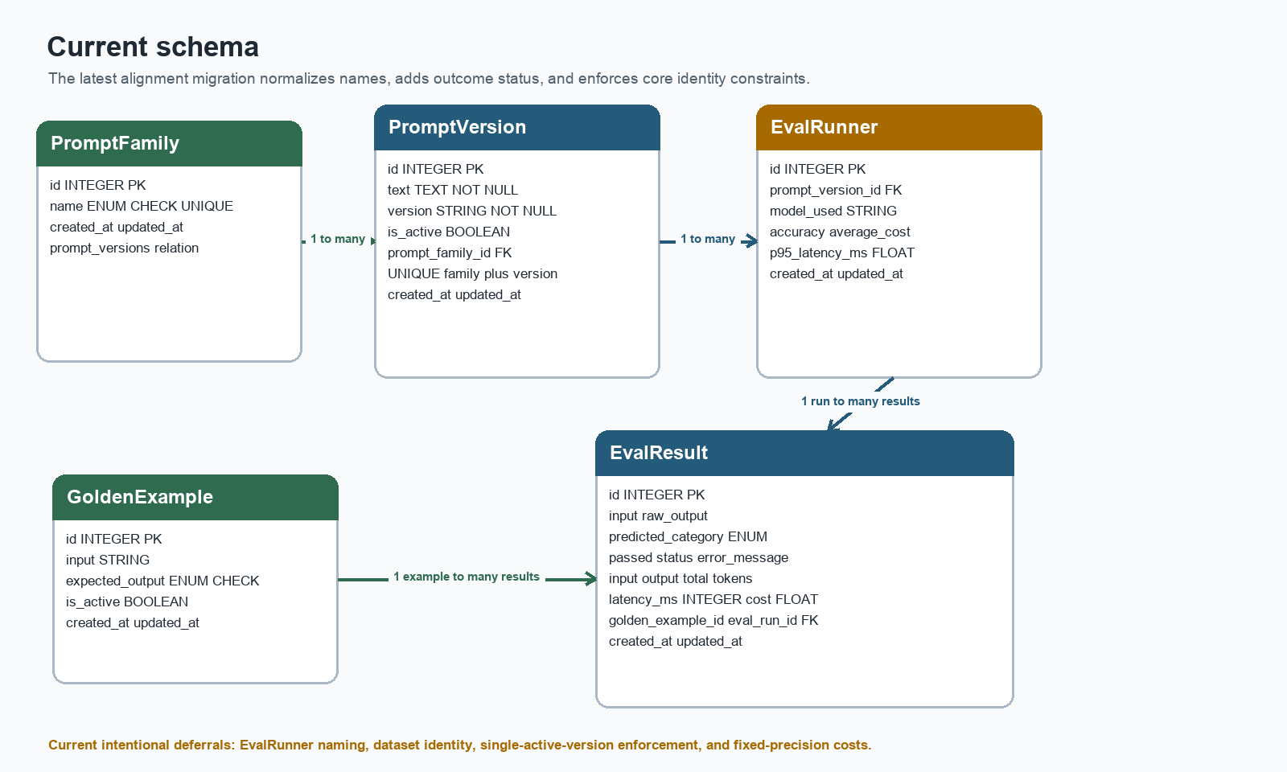
Figure 5 Current schema after alignment migration fdd324cb4b25

Current table dictionary
Table | Important columns | Purpose and integrity
prompt_families | id; name; created_at; updated_at | One row per allowed task family. Name is non-null, enum-checked, and unique.
prompt_versions | id; text; version; is_active; prompt_family_id; timestamps | Immutable prompt candidate belonging to one family. Family plus version is unique.
golden_examples | id; input; expected_output; is_active; timestamps | Objective ground truth for classification.
eval_runs | id; prompt_version_id; model_used; accuracy; average_cost; p95_latency_ms; timestamps | Aggregate evaluation record tied to one prompt version and model.
eval_results | input; predicted_category; raw_output; tokens; passed; latency_ms; cost; error_message; status; two FKs; timestamps | Per-example evidence used to explain aggregate metrics and failures.

Current relationship behavior
Parent | Child | Cardinality | ORM navigation
PromptFamily | PromptVersion | One to many | family.prompt_versions and version.prompt_family
PromptVersion | EvalRunner | One to many | version.eval_runners and run.prompt_version
EvalRunner | EvalResult | One to many | run.eval_results and result.eval_run
GoldenExample | EvalResult | One to many | example.eval_results and result.golden_example

Raw output and normalized prediction
The current result separates raw_output from predicted_category. Raw output preserves exactly what the provider returned. Predicted category stores the normalized value used for scoring. If the model returns 'This appears to be BUG', the parser can preserve that sentence as raw_output and store BUG as predicted_category. If parsing fails, predicted_category can remain null while raw_output and status explain the failure.
Raw output | Predicted category | Status | Passed
BUG | BUG | COMPLETED | True or False after comparison
This appears to be BUG | BUG | COMPLETED | True or False
BUG or SPT | NULL | INVALID_OUTPUT | Usually False or unscored by policy
NULL | NULL | MODEL_ERROR or TIMEOUT | Should follow the metric policy

Status and correctness are separate
Status describes whether the model call and parser completed. Passed describes whether a valid prediction matched the expected category. A completed result can still be incorrect. INVALID_OUTPUT, MODEL_ERROR, and TIMEOUT explain why no normal prediction was produced. The evaluation policy must state whether these outcomes count as failures in the accuracy denominator.

Model practice review
Practice | Status | Current assessment
Singular ORM classes | Implemented | PromptVersion, PromptFamily, GoldenExample, and EvalResult are singular. EvalRunner is intentionally deferred.
Plural table names | Implemented | prompt_versions, prompt_families, golden_examples, eval_results, and eval_runs remain plural.
Foreign key on many side | Implemented | prompt_versions.prompt_family_id establishes one family to many versions.
Run prompt traceability | Implemented | eval_runs.prompt_version_id links every metric aggregate to one prompt version.
Model identity | Implemented | eval_runs.model_used records the model label.
Bidirectional relationships | Implemented | All four relationship pairs use matching back_populates.
Composite version identity | Implemented | uq_prompt_versions_family_version prevents duplicate versions within one family.
Unique family identity | Implemented | PromptFamily.name is unique.
Non-native enums | Implemented | Current models use VARCHAR-backed enums with CHECK constraints.
Numeric latency | Implemented | Per-result latency is integer milliseconds; p95 is float milliseconds.
Token accounting | Implemented | Input, output, and total token counts are present.
Output audit trail | Implemented | Raw output, normalized predicted category, status, and error message are separate.
Server-side creation timestamps | Implemented in model | server_default=func.now() is declared; confirm migrations actually installed defaults in PostgreSQL.
Automatic update timestamp | Partially implemented | onupdate=func.now() works through SQLAlchemy updates, not arbitrary raw SQL. No PostgreSQL trigger exists.
Required Boolean defaults | Partially implemented | PromptVersion.is_active has a default but is not explicitly nullable=False; GoldenExample.is_active is non-null but has no default.
Single active version per family | Open | The schema does not prevent two active versions in one family. Service logic or a partial unique index is still required.
Dataset identity | Open | EvalRunner has no dataset name, version, or dataset foreign key.
Cost precision and naming | Open | cost and average_cost remain Float and omit a currency suffix such as _usd.
Accuracy scale | Open | No constraint states whether accuracy uses 0 to 1 or 0 to 100.
Run lifecycle | Open | EvalRunner has no pending, running, completed, or failed status and no run-level error field.
Derived token consistency | Open | No constraint or service rule guarantees total_tokens equals input_tokens plus output_tokens.

Defaults and nullability
Defaults should represent legitimate domain values, not hide missing relationships. Defaults of zero are reasonable for counters when zero means measured absence. Foreign keys must never default to IDs such as 1 or 2 because those rows may not exist or may represent the wrong parent. Required business fields such as prompt text and model identity should not default to an empty string.
A Python default is applied when SQLAlchemy creates an object. A server default is applied by PostgreSQL during INSERT. A migration backfill repairs existing rows. These mechanisms solve different problems and should not be substituted for one another.

Money and measurement types
- Integer milliseconds are appropriate for individual request latency when sub-millisecond precision is unnecessary.
- Float is appropriate for p95 latency because percentile algorithms may interpolate between observations.
- Fixed-precision Numeric or Decimal is preferable to Float for money when exact accounting matters.
- Accuracy should use one documented scale and ideally a CHECK constraint, such as 0.0 through 1.0.

Alembic practices learned

Autogenerate is a draft
Autogenerate compares Base.metadata with the connected database. It is effective at finding structural drift, but it cannot infer intent. It does not know that two column names represent a rename, whether invalid values should be discarded, how old enum values map to new ones, or which row should own a new foreign key. Every generated revision requires manual review before upgrade.

Add backfill enforce
1. Add the new column as nullable so existing rows remain valid.
2. Populate the column from a trustworthy source or deterministic rule.
3. Validate that no null values remain.
4. Alter the column to nullable=False.
5. Add the foreign key, unique constraint, or check constraint after the data satisfies it.
The timestamp and token migrations used this sequence. The relationship migrations also used it, but hard-coded parent IDs were development shortcuts rather than portable data migrations.

Explicit PostgreSQL casts
VARCHAR to BOOLEAN: passed::boolean
BOOLEAN to VARCHAR: passed::text
Native enum to VARCHAR: expected_output::text
VARCHAR to quoted native enum: expected_output::text::"OutputCategories"
The USING expression is part of the migration rather than models.py because it describes how existing database values move between physical types. The ORM model describes the desired destination schema.

Native and non-native enums
Property | Native PostgreSQL enum | Non-native SQLAlchemy enum
Physical storage | Standalone PostgreSQL type | VARCHAR plus CHECK constraint
Adding values | Requires PostgreSQL enum migration | Change CHECK constraint
Dropping or replacing type | Must manage the standalone type | No standalone enum type
Portability | PostgreSQL-specific | More portable
Project choice | Used initially | Current chosen strategy

SQLAlchemy stores Python enum member names by default. OutputCategories therefore stores SPT, BUG, FEAT, and BILL rather than the display strings. PromptFamilyEnum stores names such as SUPPORT_TICKET_TRIAGE unless values_callable is configured. The database constraint and seed data must use the same representation.

Upgrade and downgrade symmetry
A downgrade should reverse the upgrade in the opposite order. If upgrade creates a constraint, downgrade drops it before removing or changing the constrained column. If upgrade drops a native enum type, downgrade recreates the type before casting a column back to it. Variables declared inside upgrade are not visible inside downgrade, so enum objects must be declared in both functions or at module scope.

Constraint naming
uq_prompt_versions_family_version
uq_prompt_families_name
fk_eval_results_eval_run_id
fk_eval_results_golden_example_id
Stable names improve error messages and make downgrade deterministic. A project-wide SQLAlchemy naming convention would extend this practice to primary keys, indexes, check constraints, and foreign keys generated in future migrations.

Data storage decisions

Prompt versions should be immutable
An evaluation run points to a prompt version rather than copying every prompt field. This is reliable only if historical prompt text is not edited. A prompt change should create a new version. Rollback means activating an older row, not rewriting it. The composite unique constraint prevents two versions with the same version label inside one family.

Evaluation results should preserve evidence
- input preserves the evaluated ticket snapshot even if the source golden example changes later.
- raw_output preserves the exact model response for debugging and audit.
- predicted_category stores the normalized category used for exact-match scoring.
- passed records the correctness judgment.
- status and error_message separate invalid output, provider failure, and timeout from an ordinary wrong answer.
- token, latency, and cost fields support accuracy versus efficiency comparisons.

Run-level and result-level errors
A timeout or provider failure affecting one example belongs on EvalResult. A configuration error that prevents the entire evaluation from starting belongs on EvalRunner. The current model implements result-level status and error text. Run-level status, error count, and run-level error text remain open.

Golden dataset identity
The project has 100 balanced support-ticket examples, with 25 examples for each of SPT, BUG, FEAT, and BILL. EvalRunner does not yet identify which dataset version was used. A minimal next step is dataset_name and dataset_version on the run. A fuller design would add an EvalDataset table and associate each golden example with a dataset version.

Active prompt enforcement
is_active currently marks versions but does not guarantee that only one version in a family is active. Application logic can deactivate the current row and activate another within one transaction. A stronger PostgreSQL design uses a partial unique index on prompt_family_id where is_active is true. This remains a recommendation rather than an implemented constraint.

Deletion and history preservation
The foreign keys currently express ownership and traceability, but no explicit deletion policy is documented. Historical prompt versions, runs, and results should normally be immutable and retained. Deleting a PromptVersion that has EvalRunner rows would destroy the explanation for past measurements; deleting a GoldenExample referenced by results would weaken the audit trail. Prefer restrictive foreign keys or soft deletion for historical records. Use cascading deletes only for genuinely disposable child data and only after that lifecycle is intentional.

Indexes for evaluation queries
Unique constraints create useful indexes for prompt-family names and family/version lookup, but PostgreSQL does not automatically index every foreign-key column. As the dataset grows, consider indexes on prompt_versions.prompt_family_id, eval_runs.prompt_version_id, eval_results.eval_run_id, and eval_results.golden_example_id. Add indexes from observed query plans and real access patterns rather than automatically indexing every column.

Snapshots and references
EvalResult keeps both a foreign key to GoldenExample and an input snapshot. That duplication can be deliberate: the foreign key supports relational queries, while the snapshot preserves exactly what was sent even if editable source data later changes. The same principle suggests treating published prompt-version text and completed run configuration as immutable. If mutability is allowed, copy the exact prompt, model parameters, and dataset identity into a run configuration snapshot.

Completed changes and remaining work

Implemented in the current models
- Correct one-to-many direction from PromptFamily to PromptVersion.
- Prompt version and family ORM navigation with back_populates.
- PromptVersion to EvalRunner traceability and ORM navigation.
- GoldenExample and EvalRunner relationships to individual EvalResult rows.
- Composite uniqueness of prompt family and version.
- Unique prompt-family name.
- Singular class naming except the intentionally retained EvalRunner name.
- Singular foreign-key column names in EvalResult.
- Numeric latency with explicit millisecond naming.
- Model identity on each evaluation run.
- Input, output, and total token accounting.
- Raw output separated from normalized prediction.
- Per-result status and error message.
- Creation and update timestamps.
- Non-native enum strategy with database check constraints.
- Removal of the dummy model and table at the alignment revision.

Still open in models.py
Deferred Rename EvalRunner to EvalRun when the naming cleanup is scheduled. The current table name eval_runs already reflects the correct domain noun.
Open Add dataset identity or a dataset foreign key to each run.
Open Enforce one active prompt version per family.
Open Choose fixed-precision cost columns and explicit currency names such as cost_usd and average_cost_usd.
Open Define and constrain the accuracy scale.
Open Add run lifecycle status and run-level error information if runs are persisted before completion.
Open Make PromptVersion.is_active explicitly non-null and decide whether GoldenExample.is_active should default to true.
Open Decide whether failed calls use null or zero for latency, tokens, cost, and passed; document the denominator policy.
Open Guarantee total token consistency in service code or calculate total_tokens instead of storing it.
Open Confirm server defaults exist in the applied database, because some earlier timestamp migrations backfilled values without installing persistent server defaults.
Deferred Switch from legacy declarative_base to DeclarativeBase when desired. Base itself must remain because models and Alembic metadata depend on it.

Factories and seed script are intentionally deferred
The current factories and seed script still reference old plural class names and obsolete fields such as prompt_version_id on PromptFamily, output, latency, eval_runs_id, and golden_examples_id. They also create versions before families and generate one random result per run. These files were deliberately left for a later phase at the author's request.
The eventual seed order should be family, versions, golden examples, optional runs, then results. A production-like seed should normally stop after registry data and golden examples; the real evaluation runner should create runs and results. The seed should use Alembic-created tables rather than calling drop_all and create_all, resolve the JSON path relative to the script, avoid random foreign-key choices, and commit once at the outer transaction boundary.

Verification procedure
The author reported a successful migration run on the replacement database. The following checks form the repeatable verification sequence for future changes.
1. Run alembic heads and confirm that the migration graph has one head.
2. Run alembic current and confirm that the database revision equals the head.
3. Run alembic check and expect no new upgrade operations.
4. Configure Base.registry and confirm all relationship mappings resolve.
5. Inspect PostgreSQL foreign keys, unique constraints, nullability, and enum-backed CHECK constraints.
6. On an empty disposable database, test upgrade to head, downgrade one revision, and upgrade again.
7. After the seed script is repaired, verify row counts and relationship joins without using hard-coded IDs.

Definition of a stable schema baseline
- The complete migration chain builds a new database without manual SQL outside migrations.
- Alembic reports no drift between Base.metadata and the database.
- All ORM mappings configure successfully.
- Every required foreign key, unique constraint, check constraint, and NOT NULL rule exists in PostgreSQL.
- The upgrade preserves data where preservation is required, and downgrade behavior is either tested or explicitly documented as irreversible.
- Seeds and factories use current class names, columns, relationships, and enum values.

Next development sequence
1. Repair factories and seed.py to match the current schema.
2. Build prompt-family and prompt-version repository operations and API schemas.
3. Implement active-version switching as one transaction.
4. Define the support-ticket prompt and strict output parser.
5. Implement the provider-neutral model adapter.
6. Create the evaluation runner that records one EvalResult per golden example.
7. Calculate accuracy, average cost, and p95 latency from stored results.
8. Add pytest regression checks and a CI quality threshold.

Final learning summary
The central database-design improvement was traceability. The current schema can connect a normalized prediction and its raw evidence to a golden example, an evaluation run, a model, a prompt version, and a prompt family. The migration work demonstrated that schema intent, ORM mappings, stored data, PostgreSQL types, and reversible DDL must agree. Alembic autogenerate helped discover differences, but each difficult correction required an explicit decision about cardinality, casting, backfill values, enum lifecycle, constraint naming, or data preservation.
The next phase should preserve this discipline. The eval runner must create internally consistent result and run rows, and tests must treat database evidence as the source for quality, latency, and cost comparisons.

Complete ERD comparison
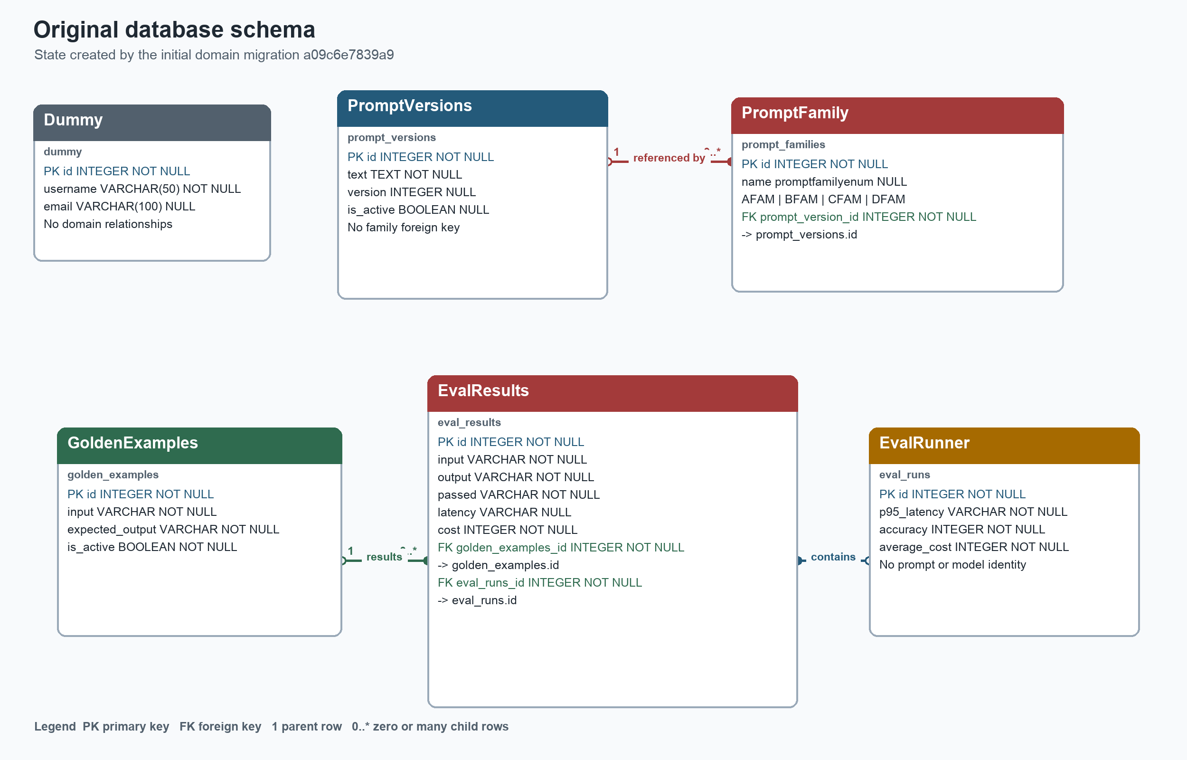
Figure 6 Complete original ERD with fields, types, keys, and reversed ownership

Complete current ERD
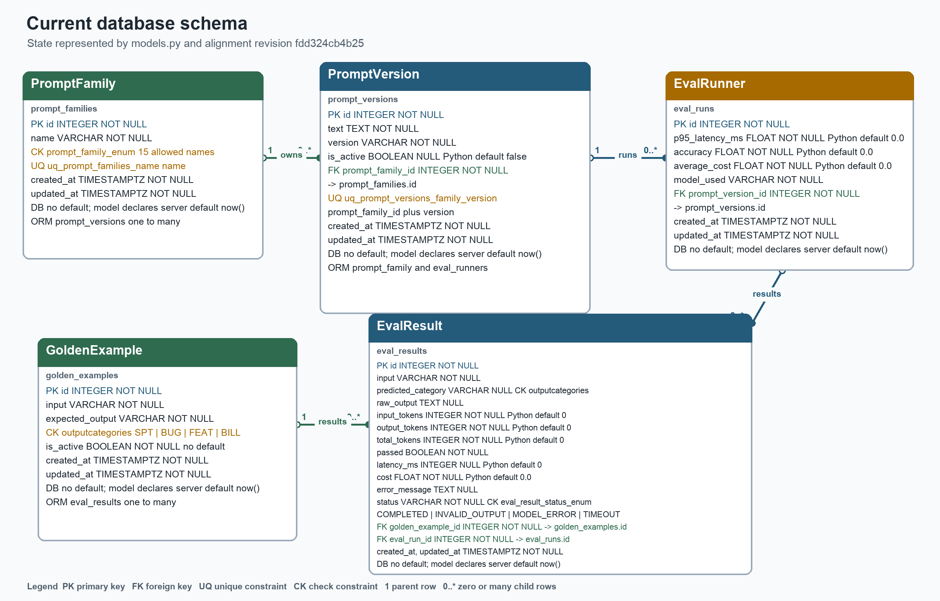
Figure 7 Complete current ERD after migration fdd324cb4b25

